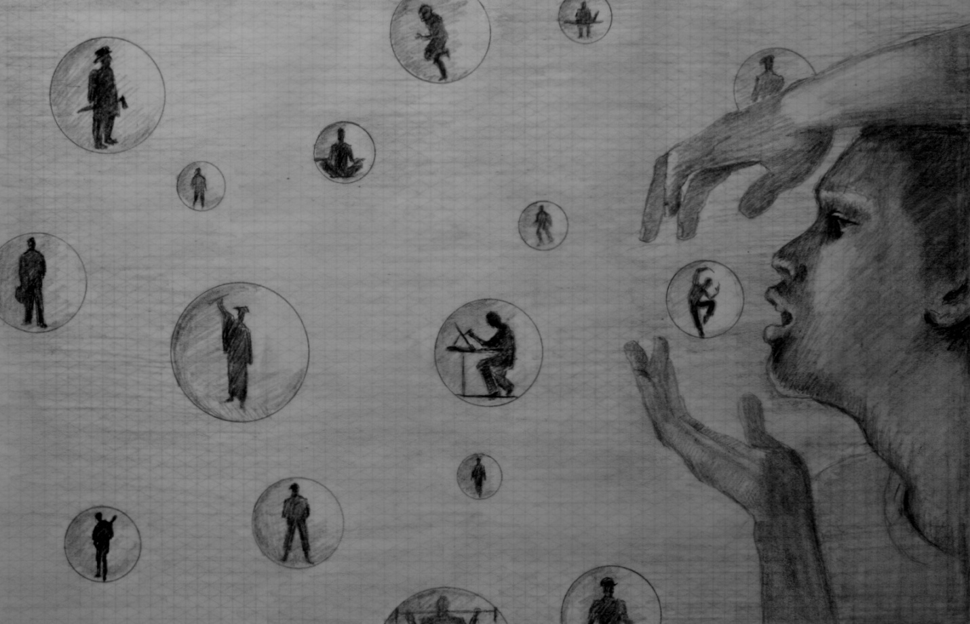
Capture Your Dream
This is my concept for the mural the David L. Moss Criminal Justice Center in Tulsa Oklahoma. The wall area is 20 ft. high by 24 ft. long in the boys section of the facility. “Capture Your Dream” is a comprehensive composition of a young man embracing his career choice. These choices symbolically are floating spheres within a dreamlike atmosphere. The boy reaches out carefully to capture the translucent colorful ball with a silhouette of a dancer, a symbol of a positive vocation he wishes to pursue. Each sphere will represent a different occupation and will be a different color. Music, visual arts, sports, military, business, civil service, culinary, health fitness and the largest sphere will represent education with a silhouette of a graduate. This mural gives the incarcerated young man a daily affirmation of seeking better choices in his life in a serene calming mural.
Submitted by Emanuel Martinez



